STATUS REPORT – Will Wu

Writer | Will Wu
Status Update Period | Week of 04/09/23 - 04/15/23
Professor | Dr. Dorothy Wang
Accomplishments for the week of (04/09/23-04/15/23)
- System Tests
  - On Friday (April 14th), we conducted various system tests, collecting IMU, RPM, and GPS data while running the car on track
  - GPS: we found that the minute measurement from the GPS sensor can give us sufficient resolution for navigation. Refer to the plots in the appendix below. We will use GPS coordinates to form a coordinate system for our navigation
  - We also ran four linear acceleration tests, during which we drive the car forward for an arbitrary amount oftime, then stop. The raw data from each sensor will be used to test our kalman filter performance
  - Onja and Payton are currently exporting these data into MATLAB for Kalman Filter verification
- Kalman Filter and Controller Implementation
  - Kalman Filter node is being implemented, using NumPy, PyKalmanFilter and ROS2
  - I introduced “message filters” to the KF node. A message filter is a built-in ROS package that synchronizes sensor readings based on time.
  - Onja and Payton will be working on the discrete-time PID controller with my help
  - We broke our system down into five parts: Kalman Filter, speed controller, pose (attitude) controller, position controller, and navigator. We aim to implement all components by Friday.
- System Trial Run This Friday
  - We aim to finish all system components by Friday, and hit the track running.

Plan for next week (04/02/23-04/08/23)
- Conduct system tests, verify Kalman Filter performance
- Design and verify GPS/IMU fusion algorithm
- Implement all PID controllers
- Finish navigator
- Prepare for system test on Friday

Topic Outline/ Progress toward deliverables
- PID Controller, linear estimator and angular estimator design. 80% done; ongoing: 2/24/23 - 4/21/23
- Kalman Filter ROS2 implementation. 50% done; ongoing: to complete by 4/15/23
- Testing Scheduled: 4/01/23 – 4/21/23
- Landmark based SLAM study Scheduled 4/01/23 – 4/27/23
Issues
- Synchronizing sensor messages can be tricky. I did a fair amount of research in using ROS message filters. I have indicated my findings in our documentation
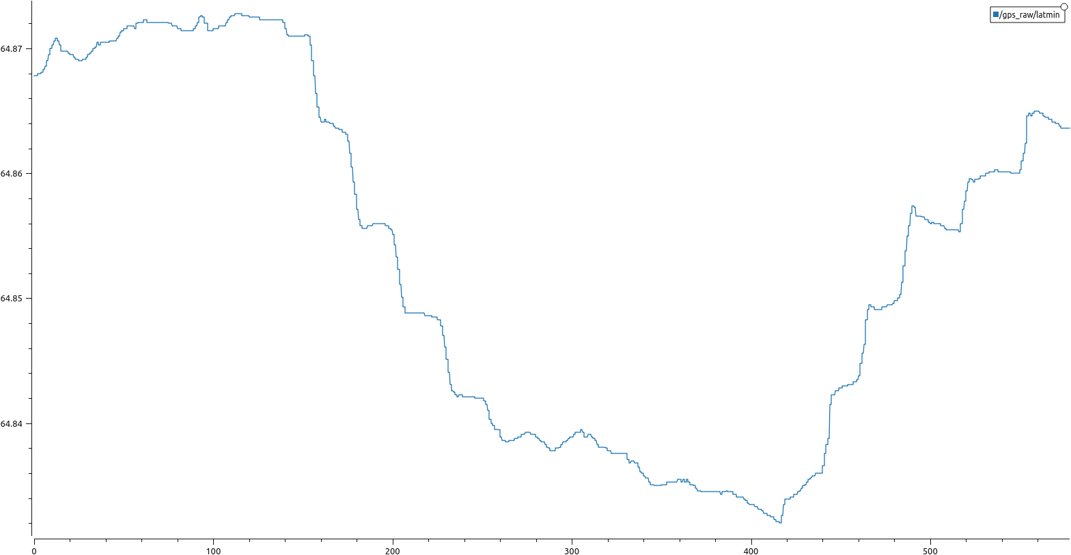
GPS: Latitude minute measurement around the track

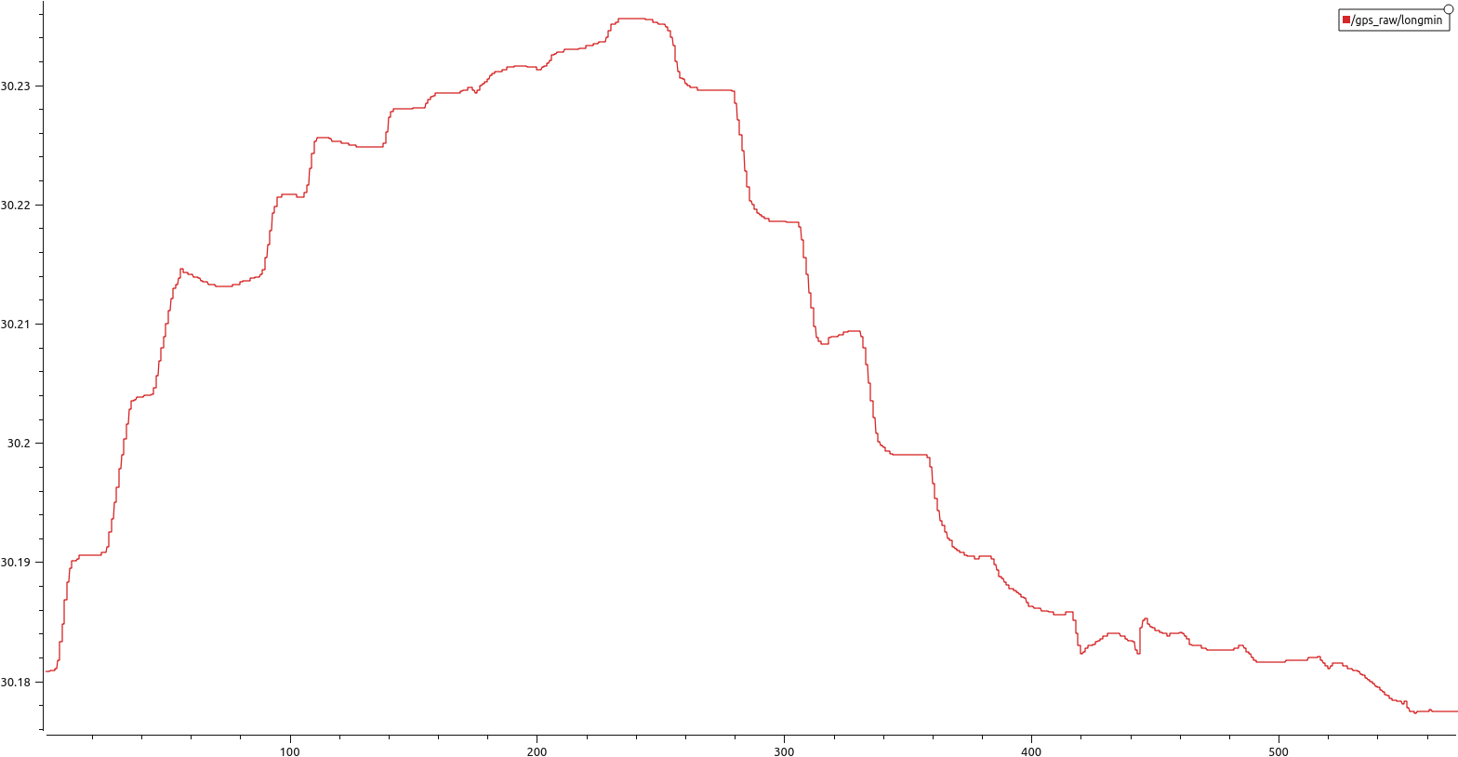
GPS: Longitude minute measurement:

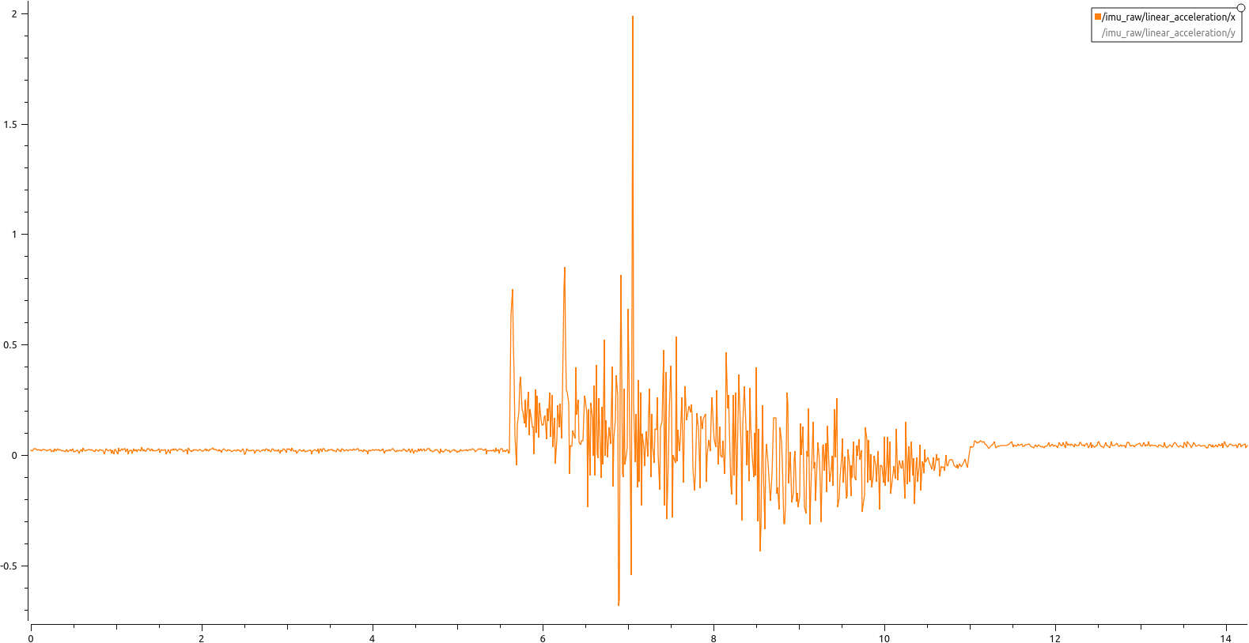
IMU data during a linear acceleration test

